**Homework #3**

1. **Propagation and Modulation**
2. The following signal was received. What type of modulation does this represent?  
   _______________________________

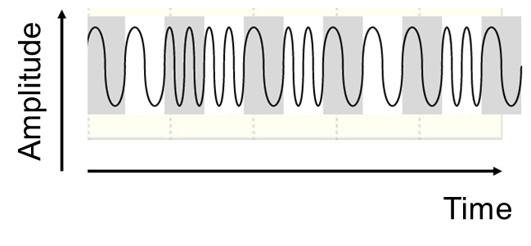

Figure 1 Modulation

1. The following is the spectrum of the signal received. What type of modulation does this represent? _________________________________



1. As an electrical signal travels along a copper twisted pair of wires the signal power gets weaker proportional to the 1/distance_traveled. Why is this and what is this effect called?
2. As a radio signal travels into space the signal power gets weaker proportional to 1/ distance_traveled**2**. Why is this and what is this effect called?
3. **Ethernet/HDLC**
4. The technique named "bit stuffing" is used to solve problems in communications. Describe what problem "bit stuffing" solves and how it solves it for the following:
   1. For Layer 1 – Physical Layer:
   2. For Layer 2 – The Data Link Layer:
5. Ethernet uses a Preamble and a Start of Frame Byte.
   1. For what purpose are these used?
   2. Are they considered as part of the overhead field of the frame?
   3. Can these be omitted every once in a while?
6. The Ethernet frame has a PAD field.
   1. What is the purpose of this field?
   2. Can this field be omitted?
7. Describe the dual use of the Length/Type field in an Ethernet Frame:
8. The HDLC Protocol uses a P/F bit.
   1. What does this bit indicate?
   2. Show an example of the use the P/F bit:
9. **Error Detection / Correction**
10. Hamming:
    1. The following represents a 15-bit Hamming code word received from the communications line.

|  |  |  |  |  |  |  |  |  |  |  |  |  |  |  |  |
| --- | --- | --- | --- | --- | --- | --- | --- | --- | --- | --- | --- | --- | --- | --- | --- |
| 15 | 14 | 13 | 12 | 11 | 10 | 9 | 8 | 7 | 6 | 5 | 4 | 3 | 2 | 1 | Bit  # |
| 0 | 0 | 1 | 0 | 0 | 1 | 1 | 0 | 1 | 0 | 0 | 1 | 1 | 1 | 1 | Bit Value |

The receiver knows that this is a Hamming Code word and we can assume that there is not more than a single bit error in this word.

What is the bit sequence of the user's data after the Hamming bits are removed and after the Hamming correction is applied to the data if there was an error? You must show all the calculations used to justify your answer.

* 1. How does the receiver locate the position of the Hamming words within the continuous stream of ones and zeros that are received? ____________________

1. Given the following user data is to be sent as a Layer 2 frame: 1000100011  
   This data is to be sent, protected by the CRC method.  
   CRC-4 will be used where the agreed upon polynomial divisor  
   will be P = 10011 = X4+X+1.  
   Show the bit sequence of the frame that is sent that includes the FCS:  
   (you must show all calculations used to justify your answer.)  
   _____________________________________
2. **Decibels**
3. If a power amplifier receives a 1mW signal at its input and amplifies it to   
   400 mW at the output, how much more power does the output have compared to the input, in decibels? ___________________________
4. A 20 MHz (BW) bandwidth communication channel, carries a signal with a 30dB (SNRdB) signal to noise ratio.
   1. What is the maximum data rate for these conditions? (show your calculations) ____**______________________**____
   2. How does the maximum data rate change if the channel bandwidth is doubled? ____________________________________
   3. How does the maximum data rate change if the SNRdB decreases to one tenth its value (÷ 10)? _________________________
   4. If the bandwidth and SNR do not change, how does the maximum data rate change if the line code changes from Binary encoded data to Manchester encoded data. ____________________________
   5. How does the maximum data rate change if the noise is completely eliminated, and goes down to zero? __________________
5. Fill in the missing values in the following table:  
   S = Signal Power  
   N = Noise Power

|  |  |  |  |  |
| --- | --- | --- | --- | --- |
|  | SNRdB | N | S |  |
|  | ***3dB*** | ***1 mW*** | ***2mW*** |  |
|  | ***10dB*** | ***6 mW*** | ***60 mW*** |  |
|  | 0dB |  | 6 mW | 3.1 |
|  | 6dB |  | 6 mW | 3.2 |
|  | 26dB | 6 mW |  | 3.3 |
|  | -3dB |  | 6 mW | 3.4 |
|  |  | 3 mW | 6 kW | 3.5 |
|  |  | 6 mW | 48 kW | 3.6 |

Table 1 ( kW = 103 W; mW = 10-3 W )

1. **Store and Forward**
2. Ti, Tp and File transfer time calculations:

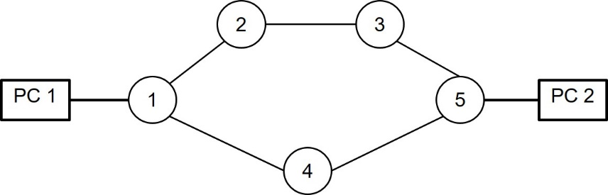

Figure 1 - Network of Switches

Figure 1 shows a Network of switches numbered 1-5 connecting PC 1 and PC 2. Suppose that all the switches in this network are "store & forward" switches. The propagation time Tp is 1 second from any switch to the neighboring switch or neighboring PC. The lines connecting the PCs and the switches operate in Full Duplex at a bit rate of 1000 bytes per second. The switches know the topology of the network. Each port on every switch has its own transmit and receive buffers of 10,000 bytes. The switches and PCs can simultaneously transmit and receive frames (information or confirmation) on each of its lines. A switch takes advantage of all the possible paths simultaneously, when transferring information to the destination. Each switch and PC returns an Ack signal immediately to its neighbor when a valid frame is received. Frame size includes 980 bytes of information + 20 bytes for the header (1000 bytes total)

* 1. Suppose that although the channels are completely reliable, the Stop&Wait protocol is used between each pair of neighboring switches or neighboring PC. Suppose that the transmission time (Ti) of the ACK confirmation message is 0 (propagation time is still 1).   
     PC 1 wants to transfer a 4900-byte file to PC 5 at maximum speed. What is the minimum time required under these conditions once PC 1 starts broadcasting the file until it finishes? (Including receipt of the acknowledge for the last frame). _______________________
  2. In an attempt to make the network more reliable, the intermediate switches (Switches 1-5) are changed so that they do not Ack frames themselves but only transfer information and confirmation (Ack) frames using the Store & Forward method. How long does it take for PC 1 to finish transmitting the file and finish receiving all the Acks? _______________________
  3. In an attempt to make the network more efficient, the PCs replace their Stop and Wait protocol with the Go Back N protocol using a maximum window size of 4. How long does it take for PC 1 to finish transmitting the file and finish receiving all the Acks? _______________________